**Basic vocabulary**

* open source

*https://www.techtarget.com/whatis/definition/open-source#:~:text=The%20term%20open%20source%20refers,freely%20available%20to%20the%20public.*

The term open source refers to any program whose source code is made available for use or modification as users or other developers see fit. Unlike proprietary software, open source software is computer software that is developed as a public, open collaboration and made freely available to the public.

source code (Source code is a group of instructions a programmer writes using computer programming languages. Once a programmer writes a line or set of source code, they can later implement it in a website, application or another type of computer program to give it instructions for functioning. For example, a coder may write a line of source code that tells a website to respond in a certain way when a user clicks on a specific part of a webpage, like a button or a hyperlink.)

[What is Source Code and What Does it Do?](https://youtu.be/exUCyp8PbD4?si=nK3s3AV6i-OwEgwb)

[*https://www.indeed.com/career-advice/career-development/what-is-source-code#:~:text=Source%20code%20is%20a%20group,give%20it%20instructions%20for%20functioning*](https://www.indeed.com/career-advice/career-development/what-is-source-code#:~:text=Source%20code%20is%20a%20group,give%20it%20instructions%20for%20functioning)*.*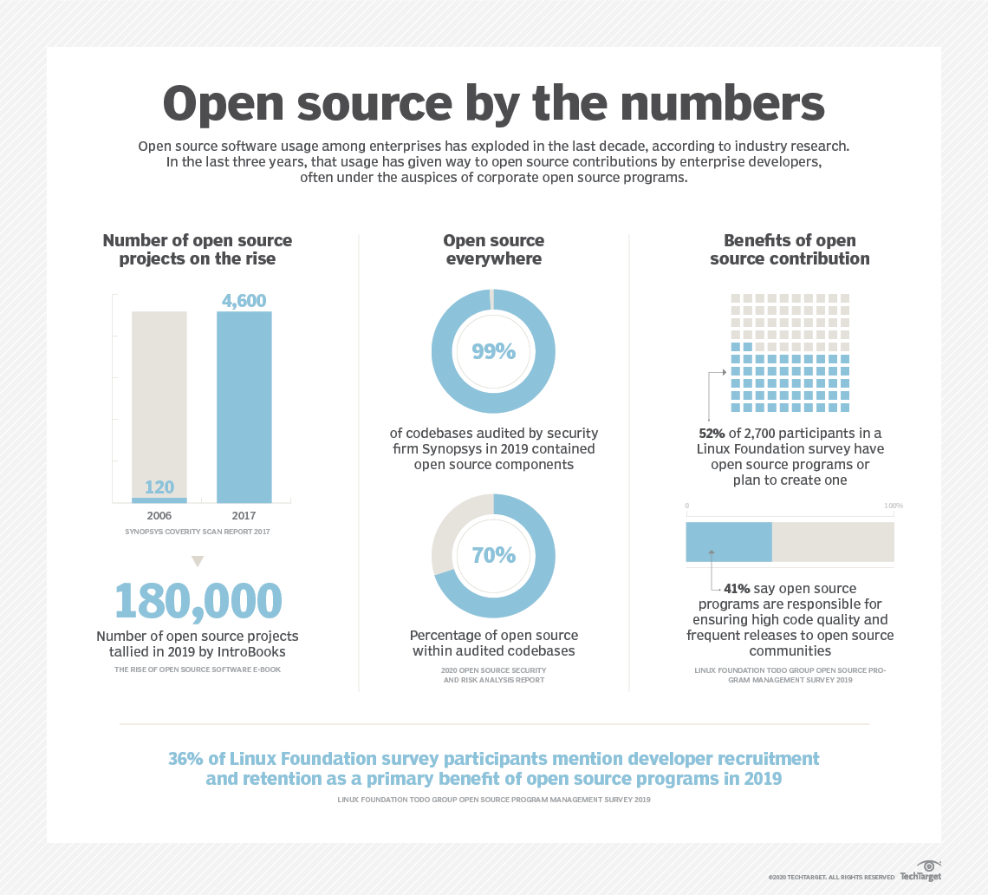

## **What are some examples of open source software licenses?**

To summarize, the *open source* definition designates that:

* An open source software license is free of charge and redistribution is allowed to anyone without any restriction.
* The source code must be made available so that the receiving party will be able to improve or modify it.
* The license can require improved versions of the software to carry a different name or version from the original software.
* The software may be ported to a new [operating system](https://www.techtarget.com/whatis/definition/operating-system-OS).

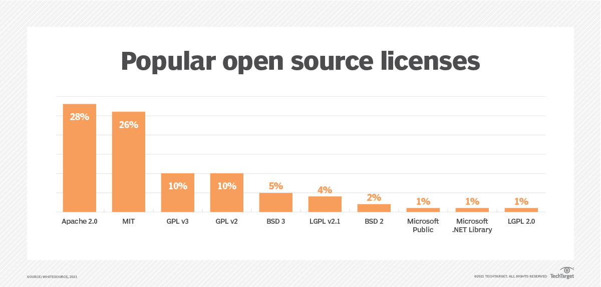

## **How is open source used in software development?**

As mentioned previously, open source has played [a large role in the software development community](https://www.techtarget.com/searchitoperations/feature/Who-profits-from-open-source-maintainers-work). In fact, a generation of open source tools have been developed and are used today by developers to help improve and troubleshoot issues with open source code during the early days of a software's development.

Open source technology is not limited to software development tools. There are a number of other popular software that falls under the open source umbrella. Examples include:

* [**Red Hat Software**](https://www.techtarget.com/searchdatacenter/definition/Red-Hat)**.** An open source software platform, and IBM derivative, that provides a variety of enterprise-level productivity applications.
* **LibreOffice.** An open source office productivity suite, similar to Microsoft Office programs.
* **GNU Image Manipulation Program.** A GNU open source image manipulation tool with similar components to Adobe Photoshop.
* [**VLC Media Player**](https://www.videolan.org/#:~:text=various%20streaming%20protocols.-,VLC%20is%20a%20free%20and%20open%20source%20cross%2Dplatform%20multimedia,files%2C%20and%20various%20streaming%20protocols.)**.** An open source audio and video file player.

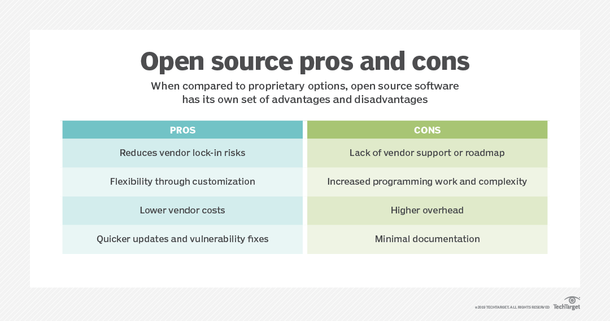

* **Drive**

*https://techterms.com/definition/drive*

A drive is a computer [component](https://techterms.com/definition/component) used to store [data](https://techterms.com/definition/data). It may be a static [storage device](https://techterms.com/definition/storagedevice) or may use removable [media](https://techterms.com/definition/media). All drives store nonvolatile data, meaning the data is not erased when the power is turned off.

Over the past several decades, drives have evolved along with other computer technologies. Below is a list of different types of computer drives.

1. 5.25 inch floppy drive - uses flexible removable media drive, stores up to 800 KB per [floppy disk](https://techterms.com/definition/floppy_disk), popular in the 1980s

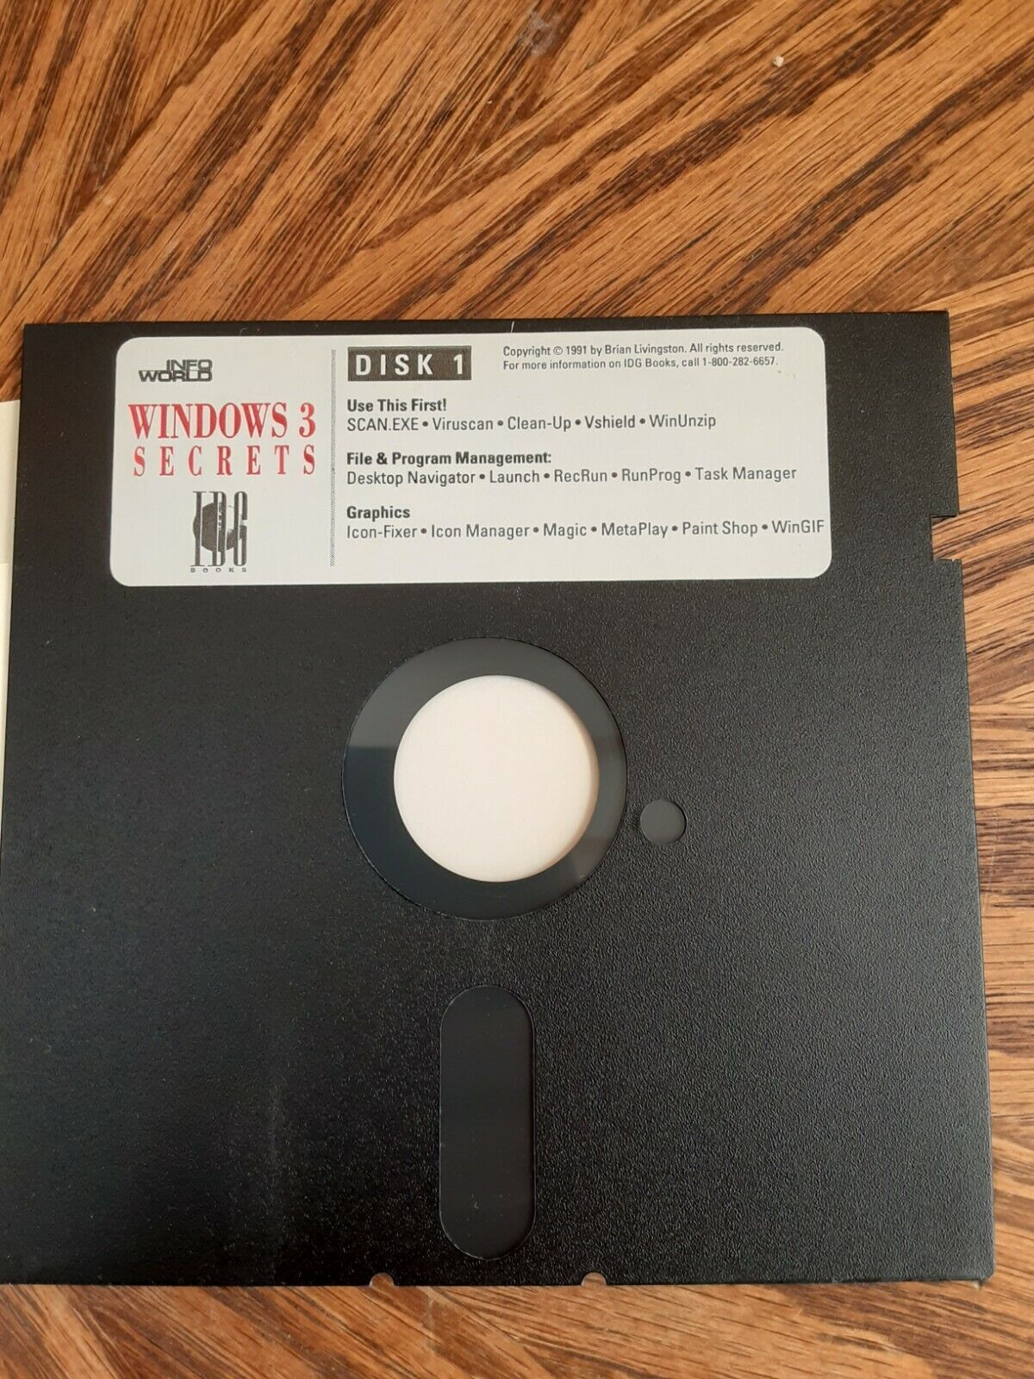

1. 3.5 inch floppy drive - uses more rigid removable media, stores up to 1.44 MB per disk, popular in the 1990s

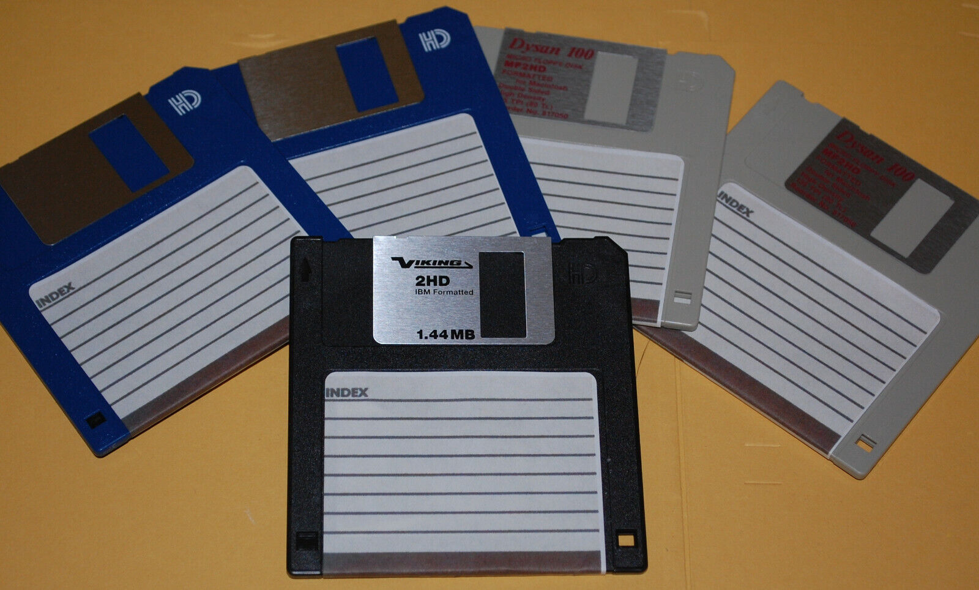

1. [Optical drive](https://techterms.com/definition/optical_drive) - uses removable [optical media](https://techterms.com/definition/optical_media) such as [CDs](https://techterms.com/definition/cd) (800 MB), [DVDs](https://techterms.com/definition/dvd) (4.7 - 17 GB), and [Blu-ray](https://techterms.com/definition/blu-ray) discs (25-50 GB), available in both [read-only](https://techterms.com/definition/read-only) and writable models, popular in the 2000s

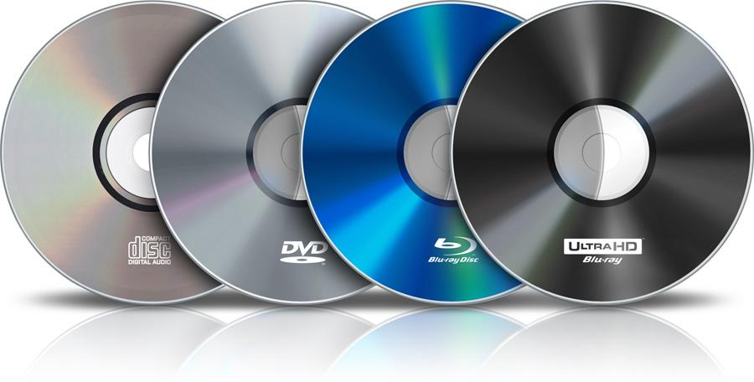

1. [Flash drive](https://techterms.com/definition/flash_drive) - a small, highly portable storage device that uses [flash memory](https://techterms.com/definition/flash_memory) and connects directly to a [USB](https://techterms.com/definition/usb) port

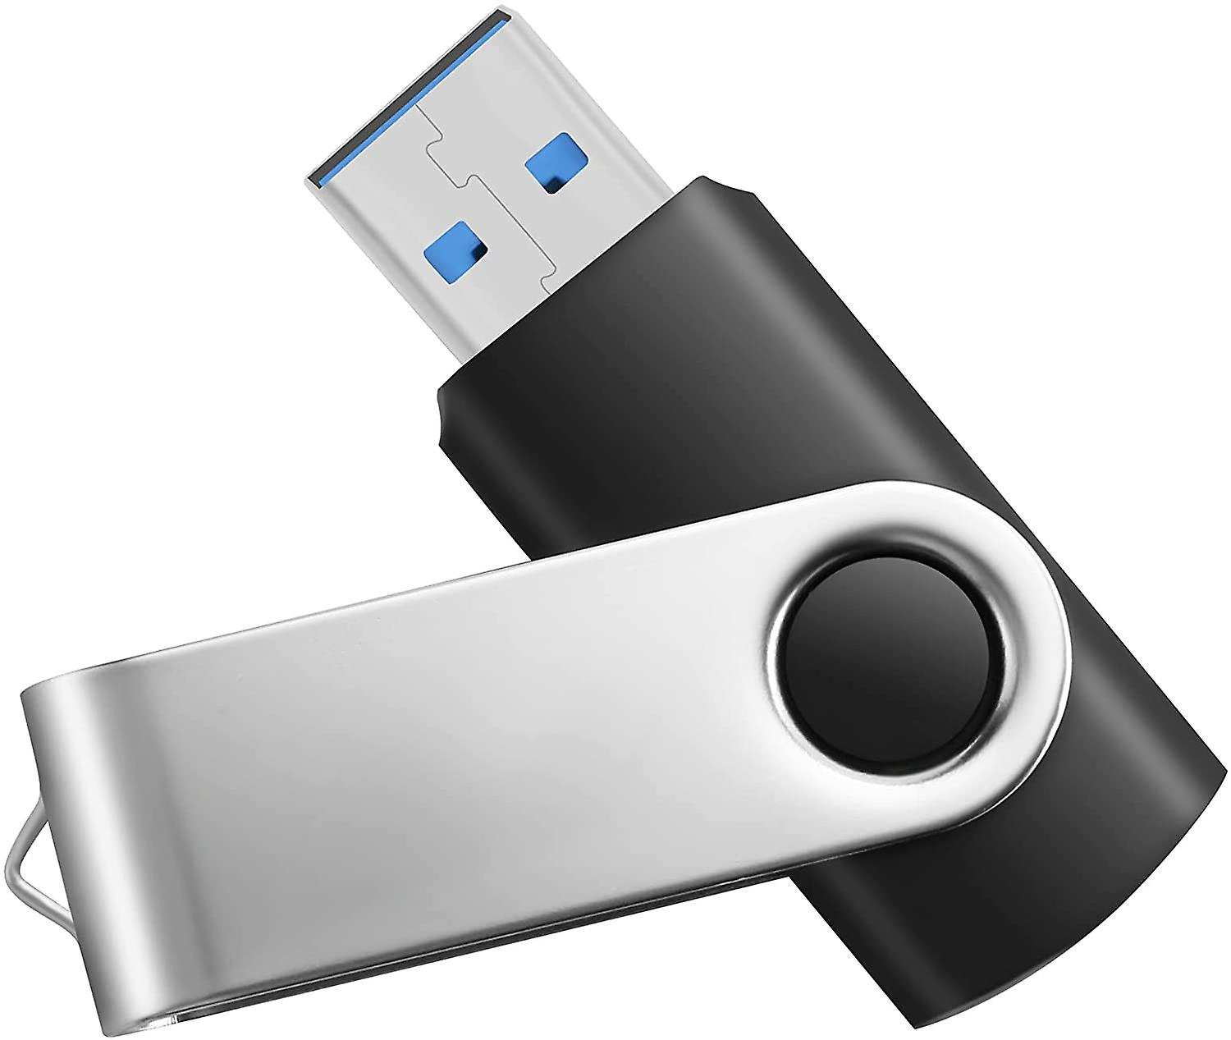

1. [HDD](https://techterms.com/definition/hdd) (hard disk drive) - the most common internal storage device used by computers over the past several decades, can store several [terabytes](https://techterms.com/definition/terabyte) (TB) of data
2. [SSD](https://techterms.com/definition/ssd) (solid state drive) - serves the same purpose as a hard drive but contains no moving parts; uses flash memory and provides faster performance than a hard drive

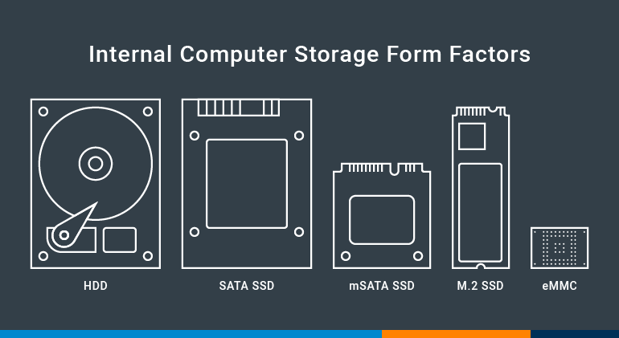

While there are many different types of drives, they are all considered [secondary memory](https://techterms.com/definition/secondary_memory) since they are not accessed directly by the [CPU](https://techterms.com/definition/cpu). Instead, when a computer reads data from a drive, the data first gets sent to the [RAM](https://techterms.com/definition/ram) so that it can be accessed more quickly. Even the fastest drives, likes SSDs, have much slower read/write speeds than RAM.

* URL

*https://developer.mozilla.org/en-US/docs/Learn/Common_questions/Web_mechanics/What_is_a_URL*

*URL* is one of the key concepts of the Web. It is the mechanism used by [browsers](https://developer.mozilla.org/en-US/docs/Glossary/Browser) to retrieve any published resource on the web.

URL stands for *Uniform Resource Locator*. A URL is nothing more than the address of a given unique resource on the Web. In theory, each valid URL points to a unique resource. Such resources can be an HTML page, a CSS document, an image, etc. In practice, there are some exceptions, the most common being a URL pointing to a resource that no longer exists or that has moved. As the resource represented by the URL and the URL itself are handled by the Web server, it is up to the owner of the web server to carefully manage that resource and its associated URL.

A URL is composed of different parts, some mandatory and others optional. The most important parts are highlighted on the URL below (details are provided in the following sections):



* **search engine**

*https://techterms.com/definition/searchengine*

**A search engine is a web-based software tool that helps locate information on the Internet. A search engine first creates an** [**index**](https://techterms.com/definition/index) **of web pages using page titles, content and other** [**metadata**](https://techterms.com/definition/metadata)**. When a user enters a** [**query**](https://techterms.com/definition/query) **into a search engine, it looks for matching pages in its index, runs an** [**algorithm**](https://techterms.com/definition/algorithm) **to rank what it finds, then presents a list of results.**

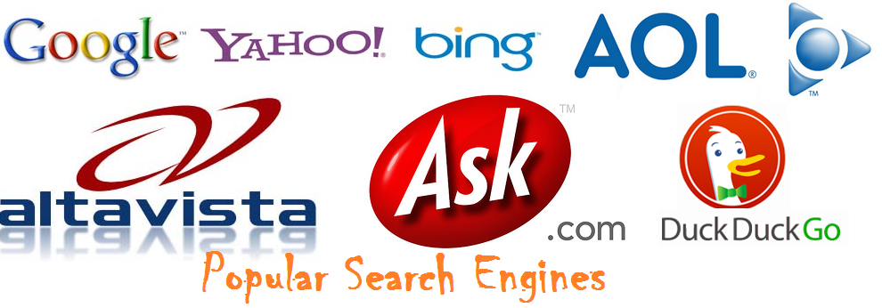

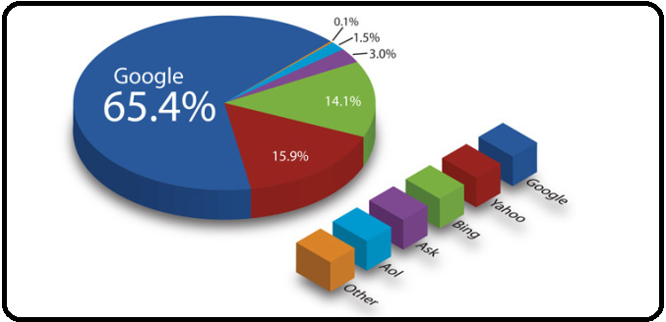

[Most Popular Search Engines 1993-2021](https://youtu.be/1a3WL1iOvnE?si=I1kyh6Z5vI0iZGoG)

* **operating system**

*https://www.mygreatlearning.com/blog/what-is-operating-system/*

**An** [**operating system**](https://www.mygreatlearning.com/blog/linux-vs-windows/) **(OS) manages all other applications and programs in a computer, and it is loaded into the computer by a boot program. It enables applications to interact with a computer’s hardware. Through a designated application programme interface, the application programmes request services from the operating system (API). The kernel is the software that contains the operating system’s core components. To run other programmes, every computer has to have at least one operating system installed.**

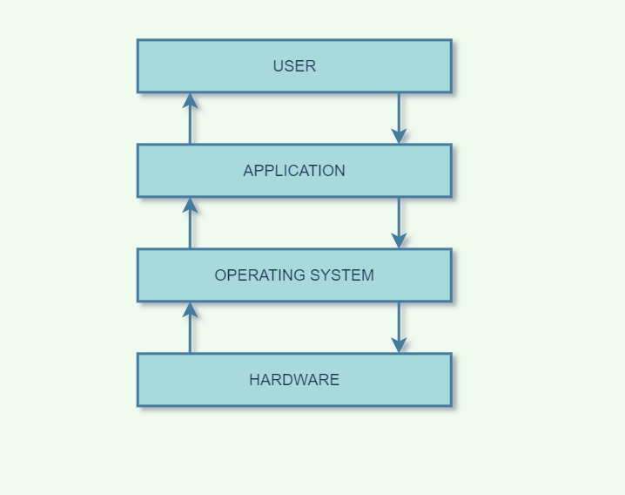

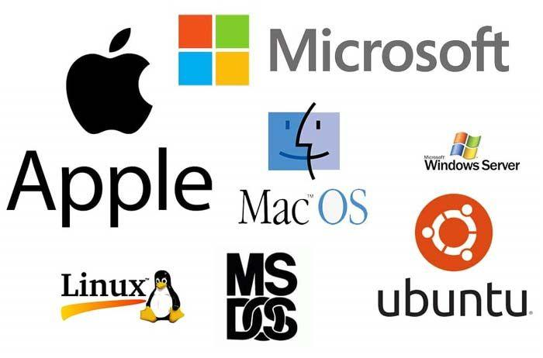

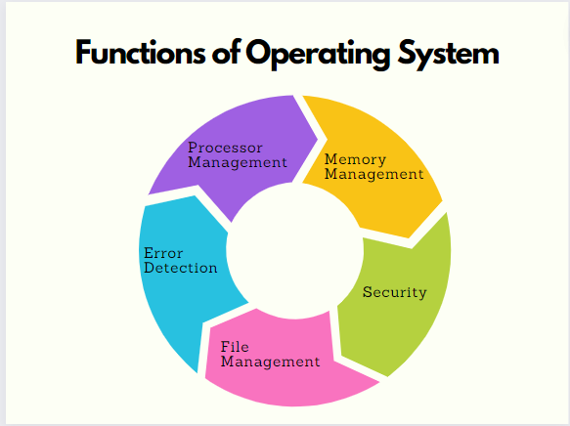

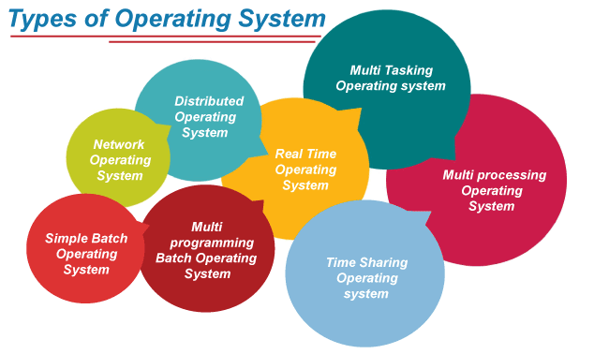

[**Types of Operating Systems (OS) - javatpoint**](https://www.javatpoint.com/types-of-operating-systems)

* **Kanban method/Trello**

[*https://asana.com/resources/what-is-kanban*](https://asana.com/resources/what-is-kanban)

[*https://www.atlassian.com/blog/trello/kanban-data-nave*](https://www.atlassian.com/blog/trello/kanban-data-nave)

**Kanban is an Agile management method built on a philosophy of** [**continuous improvement**](https://asana.com/resources/continuous-improvement)**, where work items are “pulled” from a** [**product backlog**](https://asana.com/resources/product-backlog) **into a steady flow of work. The framework is applied using Kanban boards—a form of** [**visual project management**](https://asana.com/resources/visual-project-management-kanban-timeline-calendar)**. In a Kanban board, tasks—represented as cards—move through stages of work—represented as columns. That way, a team can see where work is in real-time.**

**Kanban is especially popular with product, engineering, and software development teams. But they can be used by any team that’s interested in building a more dynamic, flexible workflow.**

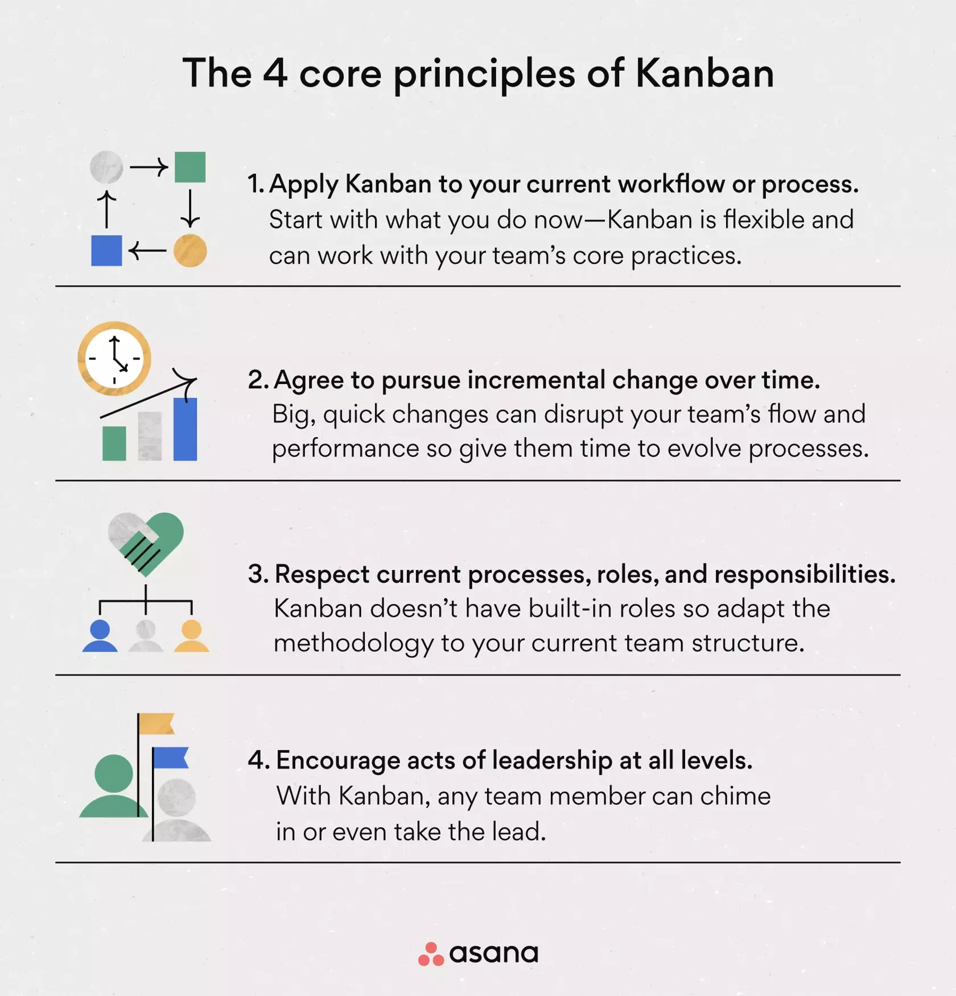

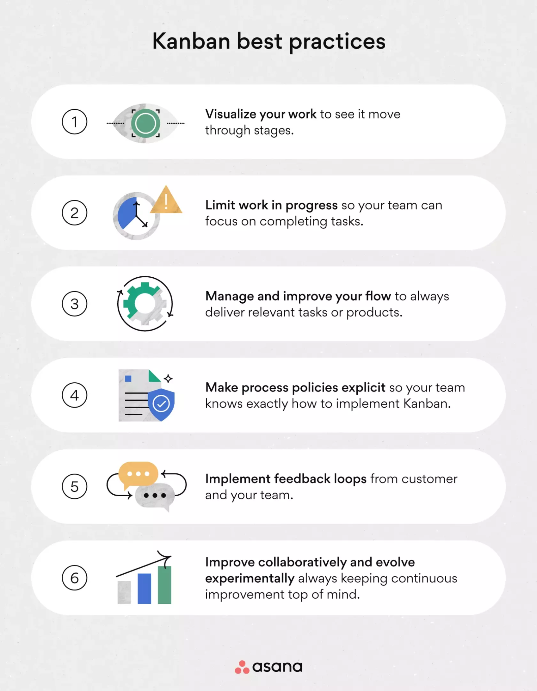



**Trello is the visual work management tool that empowers teams to ideate, plan, manage, and celebrate their work together in a collaborative, productive, and organized way.**

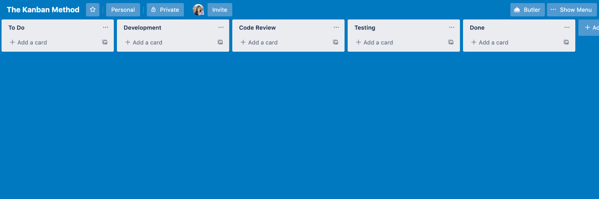



* **IP address**

[*https://techterms.com/definition/ip_address*](https://techterms.com/definition/ip_address)

*https://simitech.in/ipv4-vs-ipv6/*

**An IP address, or simply an "IP," is a unique address that identifies a device on the** [**Internet**](https://techterms.com/definition/internet) **or a** [**local network**](https://techterms.com/definition/lan)**. It allows a system to be recognized by other systems connected via the** [**Internet protocol**](https://techterms.com/definition/ip)**. There are two primary types of IP address formats used today —** [**IPv4**](https://techterms.com/definition/ipv4) **and** [**IPv6**](https://techterms.com/definition/ipv6)**.**

**IPv4**

**IPv4 is known as the fourth version of the internet protocol. It is known as one of the core protocols of standards-based internetworking techniques available on the internet. Also, available in other packet-switched networks. IPv4 is a 32-bit integer that can be expressed in the form of hexadecimal notations. These can be understood with the help of dotted decimal as a common format like x.x.x.x Here, x is known to be any value ranging between 0 and 255. For example, 192.0.0.156 is a valid ipv4 address.**

## Features Of IPv4

* IPv4 works with a concept of the connectionless protocol which is referred to as the communication between the two network endpoints for sending the message from one place to another.
* The working phenomenon of ipv4 of sending the information at the destination works by ensuring that the receiving device is ready to attain the message.
* It is helpful for creating the virtual communication layer over different devices.
* The System And Server memory utilization is less with ipv4.
* The users find it easy to remember the addresses As Compared to IPv6.
* This phenomenon is compatible with millions of devices.
* It is feasible to work with video libraries and conferences.

**IPv6**

IPv6 is the recent internet protocol version that is used as a communication protocol. This phenomenon provides the appropriate identification and location system for machines on networks. It is feasible to route traffic across the internet. This concept provides a large address space and a simple header. IPv6 utilizes the 128-bit addresses and is feasible to deliver the technical benefits for larger addressing space. The representation of addresses is done as eight groups of four hexadecimal digits which are separated by colons.

## **Features Of IPv6**

* There is no need to use network address translation in IPv6 because it consists of 340 trillion addresses. This is the reason there is no requirement for address sharing.
* It consists of a better multicast routing procedure.
* IPv6 contains more flexible options and extensions.
* It consists of a simple header format.
* The technology supports the quality of service which helps to understand how to deal with packets with distinctive service requirements.
* The administration becomes easy with IPv6 as there is no requirement for an additional protocol for example DHCP.

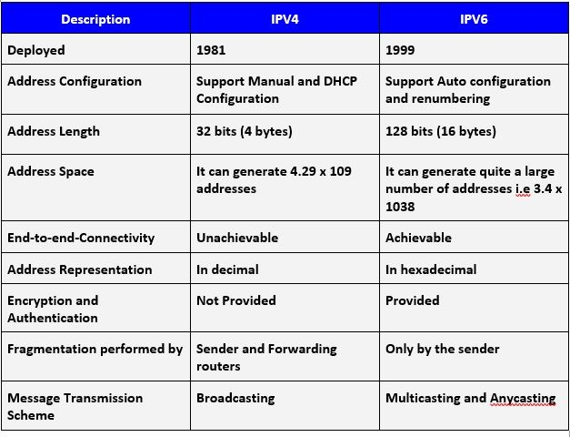

* domain

[*https://techterms.com/definition/domain*](https://techterms.com/definition/domain)

A domain is a group of computers on a [network](https://techterms.com/definition/network) that can be centrally administered with a shared set of rules. Domains may be part of a local area network ([LAN](https://techterms.com/definition/lan)), a wide area network ([WAN](https://techterms.com/definition/wan)), or a virtual private network ([VPN](https://techterms.com/definition/vpn)). [Servers](https://techterms.com/definition/server), known as domain controllers, manage users and user groups for every computer connected to their domains and are often used to manage large [enterprise](https://techterms.com/definition/enterprise) networks.

**In a simple network domain, many computers and/or workgroups are directly connected. A domain is comprised of combined systems, servers and workgroups. Multiple server types may exist in one domain – such as Web, database and print – and depend on network requirements.**

* **screenshot**

*https://www.techsmith.com/blog/screenshot/#:~:text=The%20definition%20of%20a%20screenshot%20%E2%80%94%20also%20known%20as%20a%20screen,or%20any%20other%20digital%20device.*

**A screenshot, sometimes referred to as a screencap or screengrab, is an image that shows the contents of a computer display. Screenshots let you capture exactly what you’re seeing on your screen and are often shared with others or used as a reference point later on.**

[Screenshot Meaning](https://youtu.be/QS1JRxBYlqw?si=hpdvm8jAAjnG1MAC)

* **web browser**

*https://www.techopedia.com/definition/288/web-browser*

**A web browser is a software program that allows a user to locate, access, and display web pages. In common usage, a web browser is usually shortened to “browser.”**

**Web browsers are used primarily for displaying and accessing websites on the internet, as well as other content created using languages such as Hypertext Markup Language (HTML) and Extensible Markup Language (XML).**

**Browsers translate web pages and websites delivered using Hypertext Transfer Protocol (HTTP) into human-readable content. They also have the ability to display other protocols and prefixes, such as secure HTTP (HTTPS), File Transfer Protocol (FTP), email handling (mailto:), and files (file:).**

**In addition, most browsers also support external plug-ins required to display active content, such as in-page video, audio and game content.**

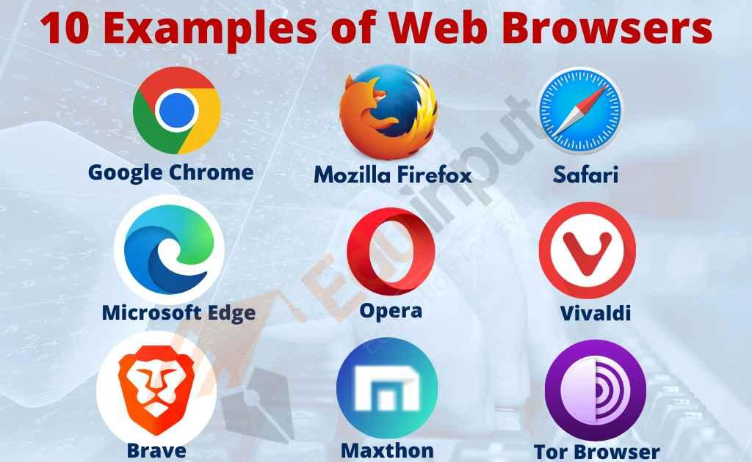

* **browser cache**

*https://pressidium.com/blog/browser-cache-work/#what-is-the-browser-cache*

The cache is a software or hardware component that is used to temporarily store values for faster future access. The browser cache is a small database of files that contains downloaded web page resources, such as images, videos, CSS, Javascript, and so on.

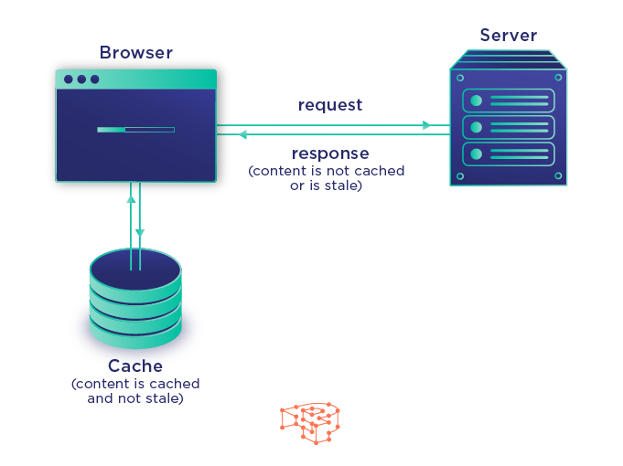

* **cookies**

*https://techterms.com/definition/cookie*

**A cookie is a small amount of data generated by a** [**website**](https://techterms.com/definition/website) **and saved by your** [**web browser**](https://techterms.com/definition/web_browser)**. Its purpose is to remember information about you, similar to a preference file created by a software** [**application**](https://techterms.com/definition/application)**.**

ADVANCED VOCABULARY

* SEO/SEA

*https://techterms.com/definition/seo*

Stands for "Search Engine Optimization." Just about every Webmaster wants his or her site to appear in the top listings of all the major search engines.

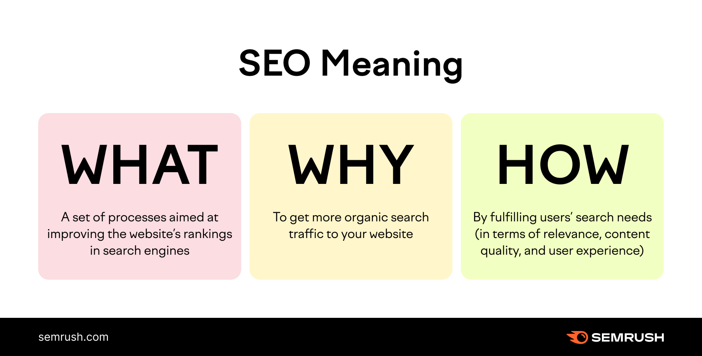

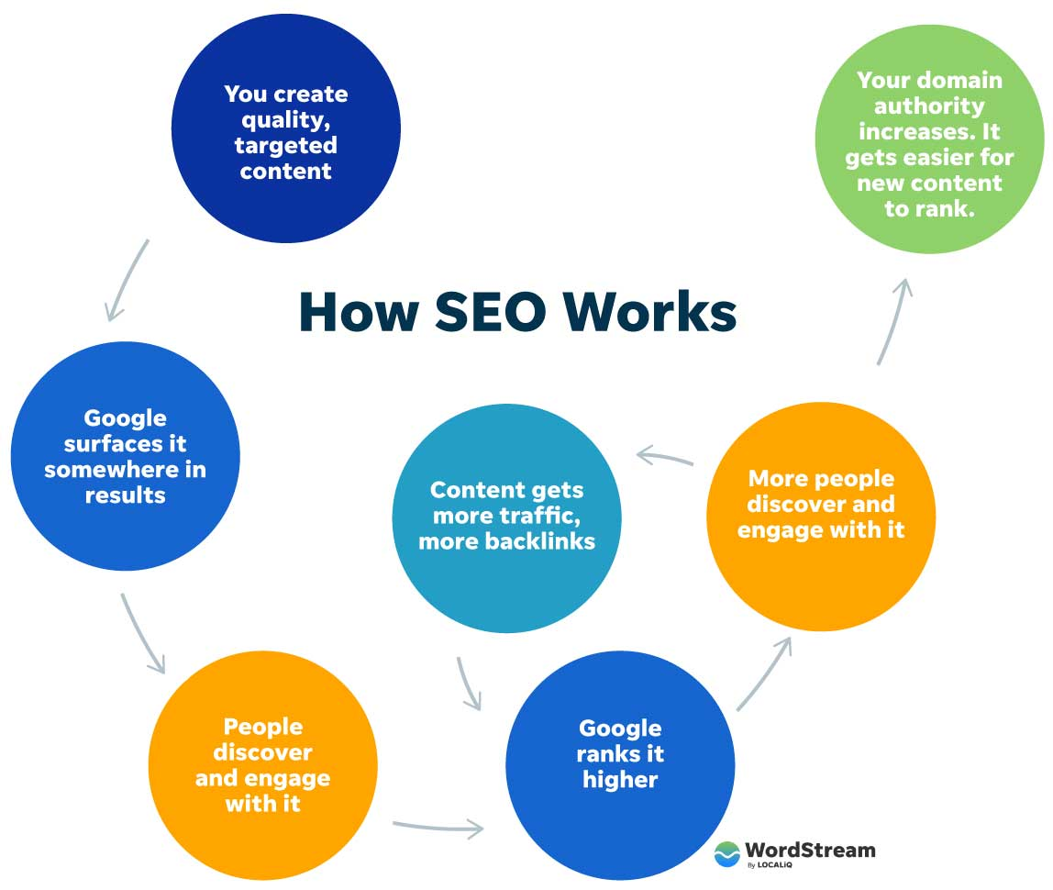

* PNG

*https://techterms.com/definition/png*

PNG is a compressed [raster graphic](https://techterms.com/definition/raster_graphic) file format that is a standard format for web graphics. It is suitable for most images, including illustrations, [icons](https://techterms.com/definition/icon), and photographs. The PNG format supports 24-bit [true color](https://techterms.com/definition/color_depth), [lossless](https://techterms.com/definition/lossless) compression, and transparency.

[What is the difference b/w JPG and PNG formats? How and where these images are used?](https://youtu.be/Us4n--oRLNo?si=4r4Z7Dajs9uZGjgq)

* Git

[*https://en.wikipedia.org/wiki/Git*](https://en.wikipedia.org/wiki/Git)

is a [distributed version control](https://en.wikipedia.org/wiki/Distributed_version_control) system[[9]](https://en.wikipedia.org/wiki/Git#cite_note-FOOTNOTEChaconStraub201429%E2%80%9331-10) that tracks changes in any set of [computer files](https://en.wikipedia.org/wiki/Computer_file), usually used for coordinating work among programmers who are collaboratively developing [source code](https://en.wikipedia.org/wiki/Source_code) during [software development](https://en.wikipedia.org/wiki/Software_development). Its goals include speed, [data integrity](https://en.wikipedia.org/wiki/Data_integrity), and support for [distributed](https://en.wikipedia.org/wiki/Distributed_computing), non-linear workflows (thousands of parallel [branches](https://en.wikipedia.org/wiki/Branching_(version_control)) running on different computers).

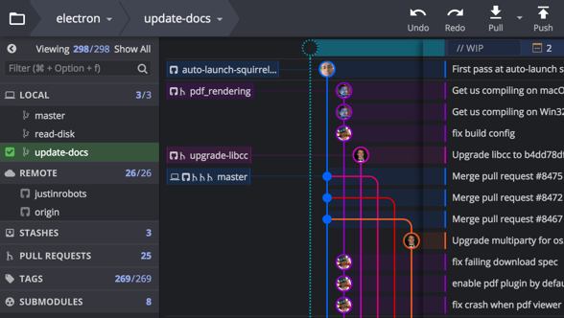

* HTML

*https://techterms.com/definition/html*

Stands for "Hypertext Markup Language." HTML is the language used to create [webpages](https://techterms.com/definition/webpage). "Hypertext" refers to the [hyperlinks](https://techterms.com/definition/hyperlink) that an HTML page may contain. "Markup language" refers to the way [tags](https://techterms.com/definition/tag) are used to define the page layout and elements within the page.



* **CSS**

[*https://techterms.com/definition/css*](https://techterms.com/definition/css)

Stands for "**Cascading Style Sheet**."

CSS is a style sheet language used for formatting content in HTML [webpages](https://techterms.com/definition/webpage). CSS style sheets can define the appearance and formatting of text, [tables](https://techterms.com/definition/table), and other elements separately from the content itself. Styles may be found within a webpage's [HTML](https://techterms.com/definition/html) file or in a separate document referenced by multiple webpages.

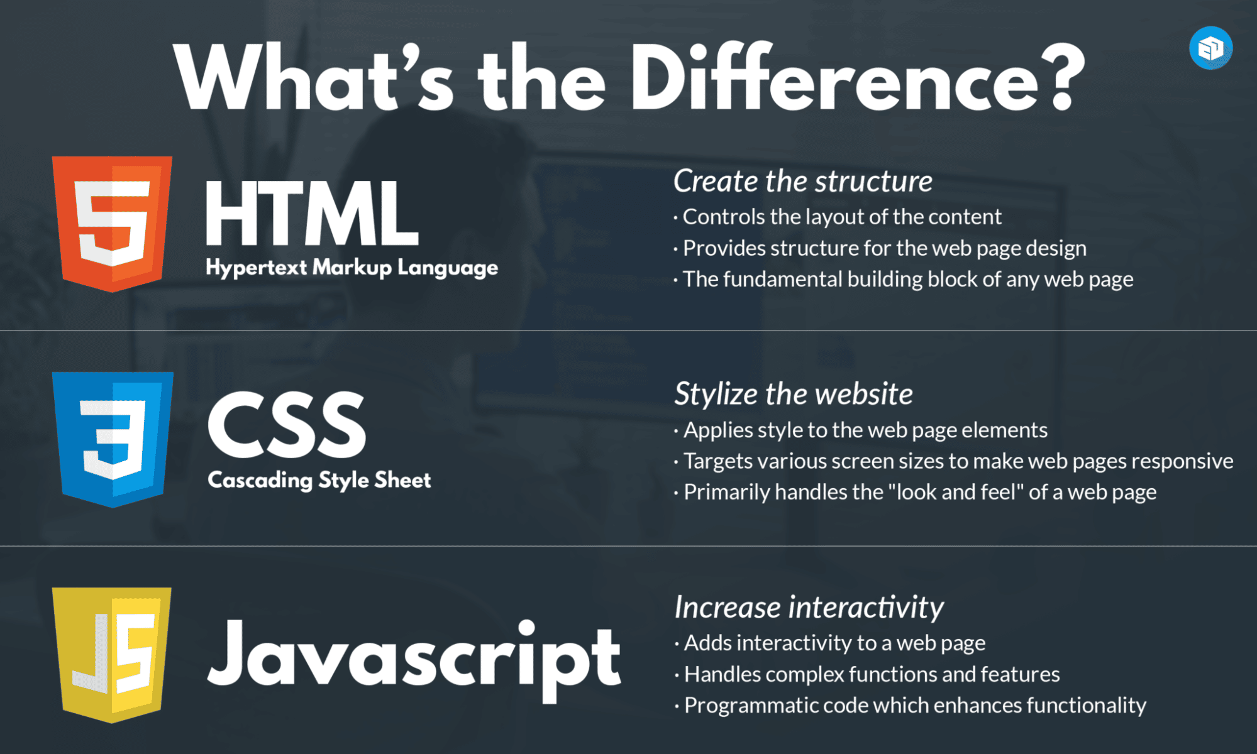

* Python

[*https://techterms.com/definition/python*](https://techterms.com/definition/python)

*https://www.coursera.org/in/articles/what-is-python-used-for-a-beginners-guide-to-using-python*

Python is a high-level programming language designed to be easy to read and simple to implement. It is [open source](https://techterms.com/definition/open_source), which means it is free to use, even for commercial applications. Python can run on Mac, Windows, and Unix systems and has also been ported to [Java](https://techterms.com/definition/java) and .NET virtual machines.

Python has created everything from Netflix’s recommendation algorithm to the software that controls self-driving cars. Python is a general-purpose language, used to create a range of applications, including data science, software and web development, automation, and improving the ease of everyday tasks.

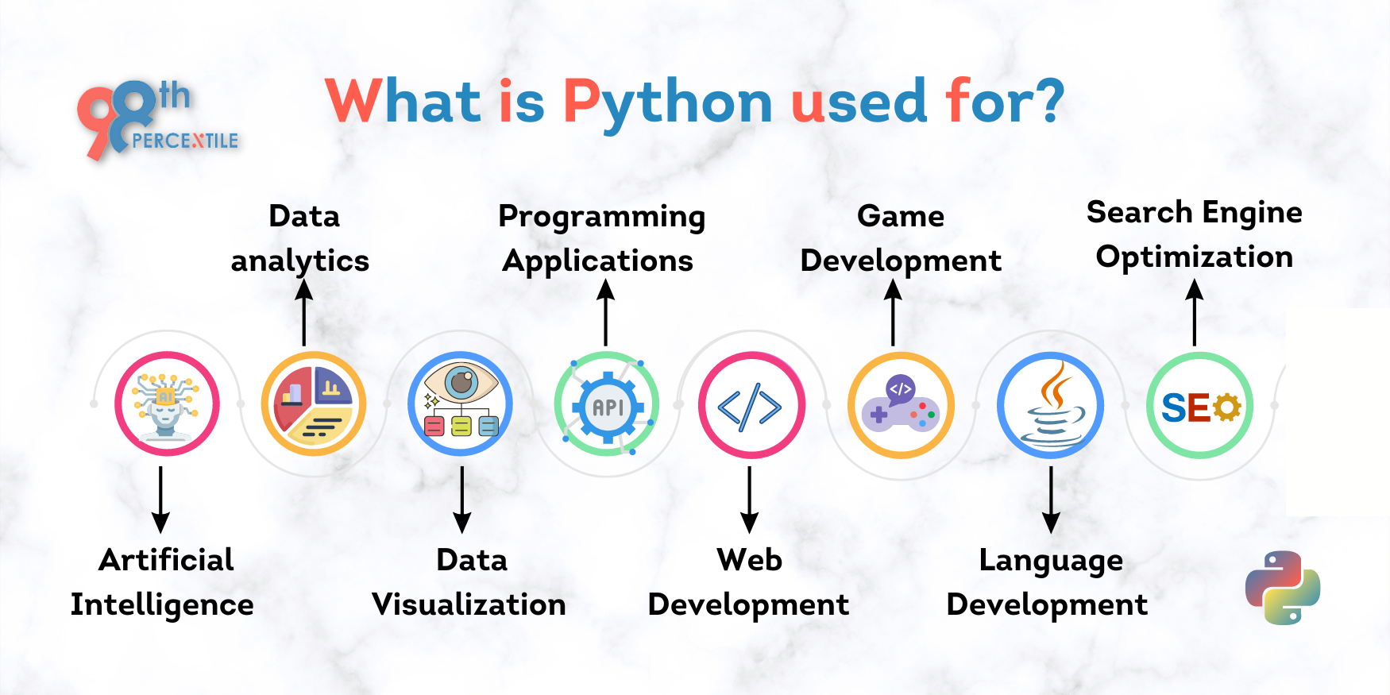

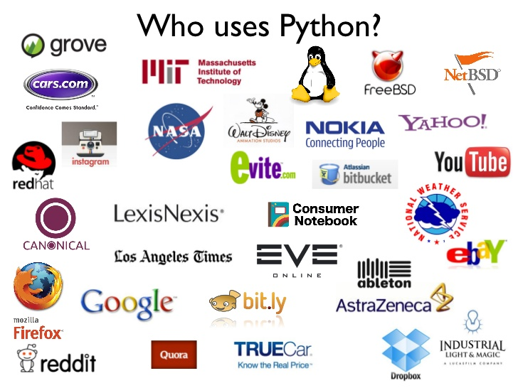

Famous People

* Ada Lovelace

*https://www.britannica.com/biography/Ada-Lovelace*

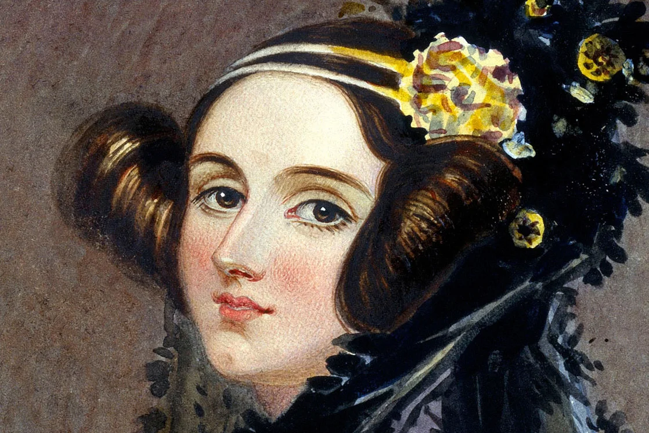

Ada Lovelace is considered the first computer programmer. English mathematician, an associate of [Charles Babbage](https://www.britannica.com/biography/Charles-Babbage), for whose [prototype](https://www.merriam-webster.com/dictionary/prototype) of a digital [computer](https://www.britannica.com/technology/computer) she created a program. She has been called the first [computer programmer](https://www.britannica.com/technology/computer-program).Even though she wrote about a computer, the Analytical Engine, that was never built, she realized that the computer could follow a series of simple instructions, a program, to perform a complex calculation.

* Mary Kenneth Keller

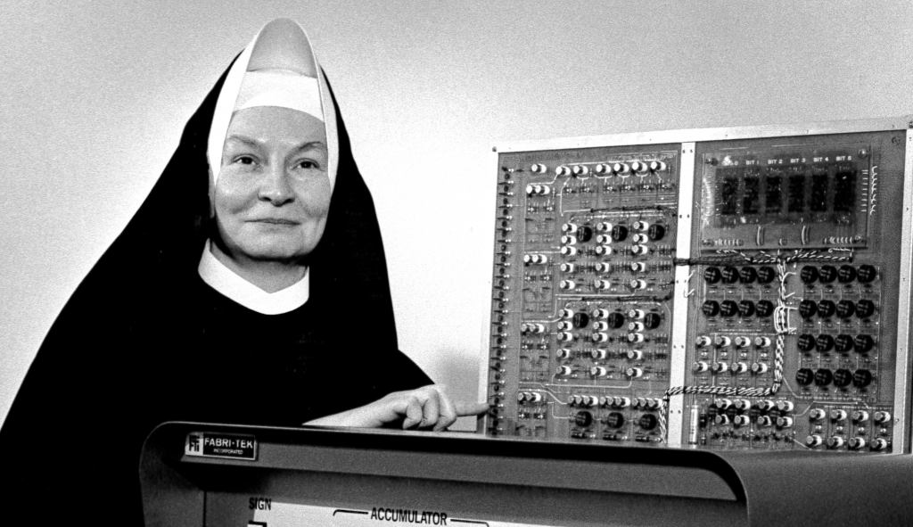

*https://en.wikipedia.org/wiki/Mary_Kenneth_Keller#:~:text=Keller%20and%20Irving%20C.,and%20Tang's%20D.Sc.*

Sister Mary Kenneth Keller was the first U.S. woman to earn a Ph. D. in computer sciences and worked to expand access to computers in education.

* Hedy Lamarr

[*https://www.womenshistory.org/education-resources/biographies/hedy-lamarr*](https://www.womenshistory.org/education-resources/biographies/hedy-lamarr)

**

Hedy Lamarr was an Austrian-American actress and inventor who pioneered the technology that would one day form the basis for today’s WiFi, GPS, and Bluetooth communication systems.

* **Margaret Hamilton**



*https://www.britannica.com/biography/Margaret-Hamilton-American-computer-scientist*

**American computer scientist who was one of the first computer software programmers; she created the term software engineer to describe her work. She helped write the computer code for the command and lunar modules used on the** [**Apollo**](https://www.britannica.com/science/Apollo-space-program) **missions to the** [**Moon**](https://www.britannica.com/place/Moon) **in the late 1960s and early ’70s.**

* **Mary Lou Jepsen**



<https://www.maryloujepsen.com/>

**Mary Lou Jepsen is a tech pioneer with over 250 patents and 50 game-changing products to her name.**

**​**

**From virtual and augmented reality systems to laptops and smartphones, from holography to health wearables, Jepsen has touched a wide range of technologies. With her current project Openwater she's working on a suite of cutting-edge diagnostics and therapeutic wearables aimed at curing cancer, mental diseases, and stroke.**

* **Alan Turing**